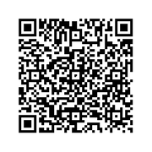
BLINDANDVISUALLY IMPAIRED(BVI)
TRANSITION AND RESOURCE FAIR 2025
JULY 12 | 9:00 AM - 12:30 PM | AGES 14-22 THE LIGHTHOUSE OF HOUSTON
3602 W DALLAS ST, HOUSTON, TX 77019

Scan the QR Code to register




Join Us at the BVI Transition and Resource Fair!
We are excited to invite you to participate as a vendor at our upcoming Blind and Visually Impaired (BVI) Transition and Resource Fair. This event is dedicated to empowering students and their families by providing valuable resources and opportunities. Here are some highlights of what students can look forward to:
Self-Advocacy and Confidence Building Skills
Adaptive Aids, Technology, and Computer Skills Orientation and Mobility
Adaptive Arts and Crafts Classes and More!
As a vendor, you will have the opportunity to connect with students, families, and other professionals, and to share your expertise and resources. Your participation will make a significant impact on the lives of those attending.
Thanks to Our Amazing Sponsors




